Sea Lilies on Ancient Mars
https://www.panspermia.org/ancientmetazoanlife.docx by Brig Klyce | Astrobiology Research Trust
3673 South Galloway Drive | Memphis TN 38111 | 1-901-489-2222 | bklyce[at]gmail.com
March 26-29, 2020, Society for Social and Conceptual Issues in Astrobiology (SSoCIA), University of Mississippi

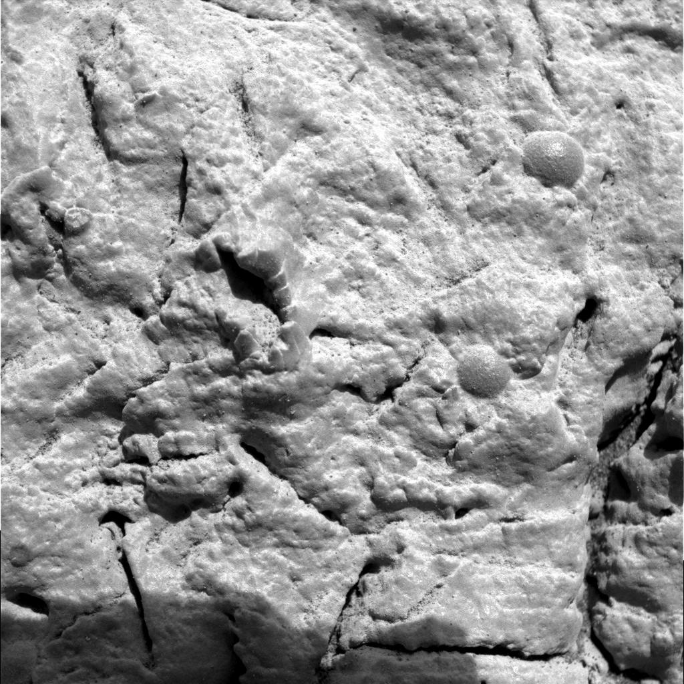
Field of view: 3cm x 3cm | https://mars.nasa.gov/mer/gallery/all/1/m/034/1M131201538EFF0500P2933M2M1.HTML

On sol 34 of the Opportunity mission to Mars (February 27, 2004), the rover was on Meridiani Planum, once a wet environment. There NASA noticed some intriguing small forms, not just “blueberries,” and commanded the Microscopic Imager to photograph them. The forms resemble fragmented fossils of crinoids commonly called “sea lilies,” filter-feeding animals related to starfish and sea urchins. Hundreds of diverse species of crinoids flourished in the Paleozoic Era on Earth. Here we compare the Mars forms and two Earthly examples. (For pointing arrows, see https://www.panspermia.org/sol34withpointers.htm.)
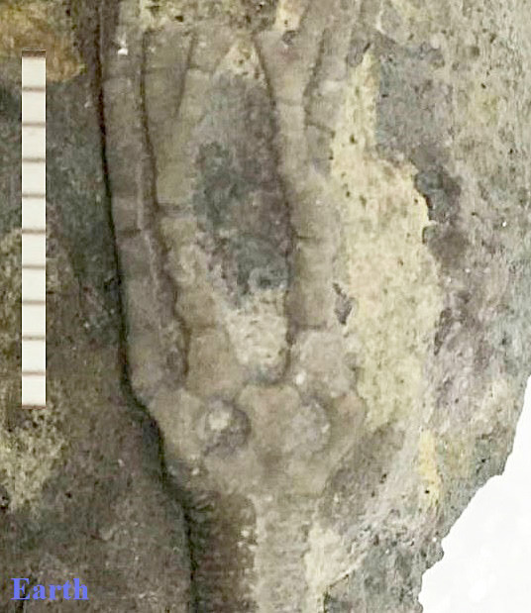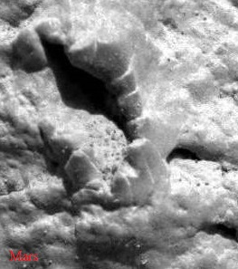
An Earthly example (left, scalebar = 10mm) is a fossilized crinoid identified as Reteocrinus elongatus, recovered in 450-million-year-old sediments in Tennessee and placed at the Harvard Museum of Comparative Zoology (https://www.panspermia.org/reteocrinusref.htm). The segmenting, branching, cup or "crown" structure and a triangular crotch are all seen, likewise arranged, on Mars (right, FOV c. 8 x 10 mm).

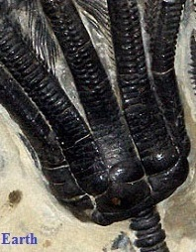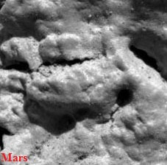
A typical crinoid has feeding arms, rising from a calyx or body cavity, attached to a stem (example, left, cropped from https://www.fossilera.com/pages/about-crinoids, no scale). The Mars fossil also appears to have a calyx, a broken stem, and possibly a short bundle of severed arms (right, FOV c. 5 x 5 mm).

Three hours after noticing the little forms, NASA destroyed them with Opportunity’s Rock Abrasion Tool.
(More at: https://www.panspermia.org/whatsnew83.htm#20151028) Thanks, Richard Hoover.

